# 

# **OOAD JAVA ASSIGNMENT ON BANKING SYSTEM DEVELOPMENT**

Functional requirements specify what a system must do, focusing on specific actions, features, and functions, while non-functional requirements define how the system should perform, detailing qualities like performance, security, reliability, and usability.

Below are the list and description of both the functional and non fuctional requirements of the banking system.

## **FUNCTIONAL REQUIREMENTS FOR THE BANKING SYSTEM**

* **CUSTOMER AND EMPLOYEE ACCOUNT MANAGEMENT**

**-**A new customer should be able to open a bank account provided with the details which are : Customer Name, E-mail address, Customer surname and lastly Customer ID

**-** The employee of the Bank should be able to manage the customers cheque account

**-**The banking system must be able to allow the user to have multiple different accounts which are : cheque account, savings account and investment account.

**-** each account should have its owner(user/employee) and shall not exist without a user.

* **TYPE OF ACCOUNTS AVAILABLE**

**-Savings Account:** The customer may open this account and is able to make deposits, but unable to make withdrawals. The account is also subjected to having ainterest of 0.05%.

**-Investment Account:** the customer may open this account with an initial deposit of P500. This account both allows deposits and withdrawals with a monthly interest of 5%

**-Cheque Account:** The customer may open this account and is required to be a working customer, hence need to provide details of the company(company name and address) and used for payments. Deposits and withdrawals are allowed.

* **DEPOSITS AND WITHDRAWALS**

**-**The customer should be able to make deposits and withdrawals with any of the accounts(withdrawals prohibited under the savings account).

* **INTEREST PAYMENTS**

-The fixed monthly interests are paid correctly, 0.05% for the savings account and 5% for the investment account. No interest offered for the cheque account.

## **NON-FUNCTIONAL REQUIREMENTS FOR THE BANKING SYSTEM**

* **SECURITY-** All accounts must be secured and protected from unauthorized access by using the username and password which is also used as login details to access the bank account.
* **PERFOMANCE-** All processes such as deposits and withdrawals and calculating interests depend should be instant and efficient.
* **USABILITY-** The GUI should be as simple and interactive.

## **USE CASE DIAGRAM FOR THE BANKING SOFTWARE**

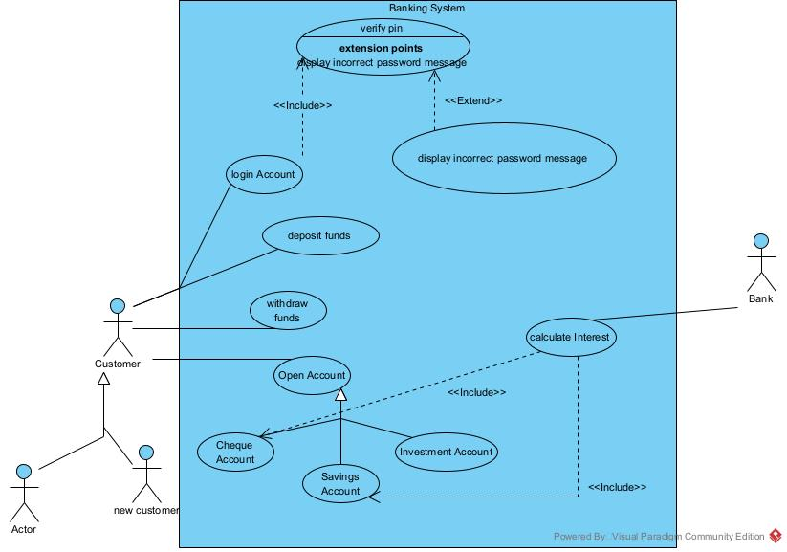

## **CLASS DIAGRAM FOR THE BANKING SYSTEM**

* Below is a representation through a class diagram on the development of the banking system.

## 

## **DEPOSIT SEQUENCE IN THE BANKING SYSTEM**

## **APPENDIX ON THE REQUIREMENTS FOR BUILDING THE BANKING SOFTWARE**

Appendix: Interview Record

**DATE:** 19 Sept. 25

**INTERVIEWER:** PETER GWALIDI

**INTERVIEWEE:** THEMBA MOENG

1 What are the most important services the banking system should provide to the customers?

:The customers must be able to register, create accounts and securely log in to their bank accounts to the system

2 what are the activites the customers should be able to do once they manage to open an account with the bank?

:They should be able to view balance, deposit and make withdrawals, also transfer funds from one account to the other.

3 Should the system keep track of past transactions?

:Yes,customers should be able to both get their tansaction history and to download the bank statements.

4 What security features should be included?

:The password and the username would be the best security feature for both preventing unautharized access and keeping the account secure